**Java Introduction**

## **What is Java?**

Java is a popular programming language, created in 1995.

It is owned by Oracle, and more than **3 billion** devices run Java.

It is used for:

* Mobile applications (specially Android apps)
* Desktop applications
* Web applications
* Web servers and application servers
* Games
* Database connection
* And much, much more!

## **Why Use Java?**

* Java works on different platforms (Windows, Mac, Linux, Raspberry Pi, etc.)
* It is one of the most popular programming language in the world
* It is easy to learn and simple to use
* It is open-source and free
* It is secure, fast and powerful
* It has a huge community support (tens of millions of developers)
* Java is an object oriented language which gives a clear structure to programs and allows code to be reused, lowering development costs
* As Java is close to [C++](https://www.w3schools.com/cpp/default.asp) and [C#](https://www.w3schools.com/cs/default.asp), it makes it easy for programmers to switch to Java or vice versa

## **Java Syntax**

public class sample {

public static void main(String[] args) {

System.out.println("Hello World");

}

}

# Java Comments

## **Single-line Comments**

Single-line comments start with two forward slashes (//).

## **Java Multi-line Comments**

Multi-line comments start with /* and ends with */.

# Java Variables

## **Java Variables**

Variables are containers for storing data values.

In Java, there are different **types** of variables, for example:

* String - stores text, such as "Hello". String values are surrounded by double quotes
* int - stores integers (whole numbers), without decimals, such as 123 or -123
* float - stores floating point numbers, with decimals, such as 19.99 or -19.99
* char - stores single characters, such as 'a' or 'B'. Char values are surrounded by single quotes
* boolean - stores values with two states: true or false

# Java Data Types

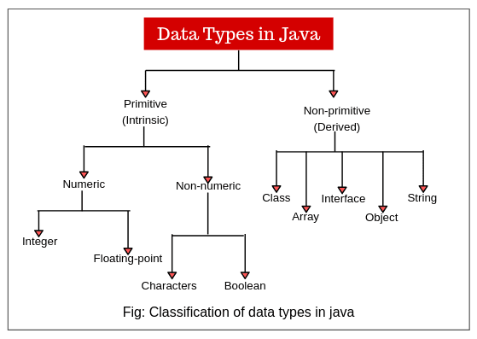

# Java Type Casting

Type casting is when you assign a value of one primitive data type to another type.

In Java, there are two types of casting:

* **Widening Casting** (automatically) - converting a smaller type to a larger type size  
  byte -> short -> char -> int -> long -> float -> double
* **Narrowing Casting** (manually) - converting a larger type to a smaller size type  
  double -> float -> long -> int -> char -> short -> byte

## **Java Operators**

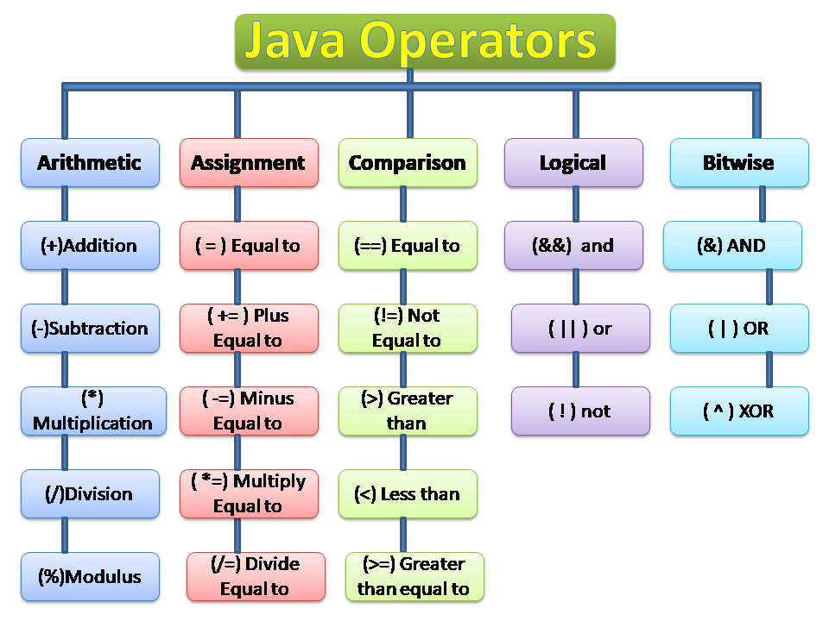

**Control Statements**

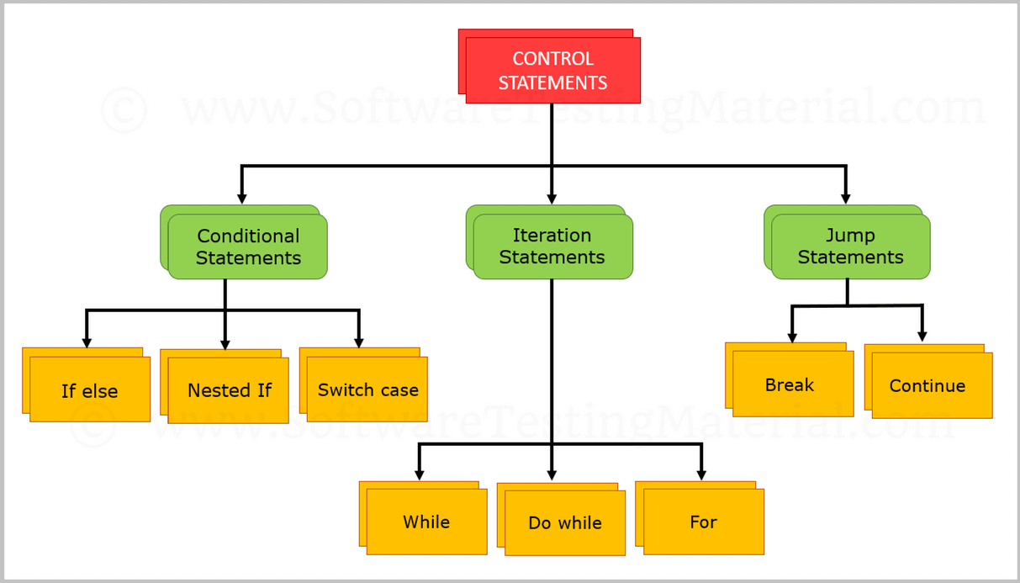

## **Java Strings**

Strings are used for storing text.

A String variable contains a collection of characters surrounded by double quotes

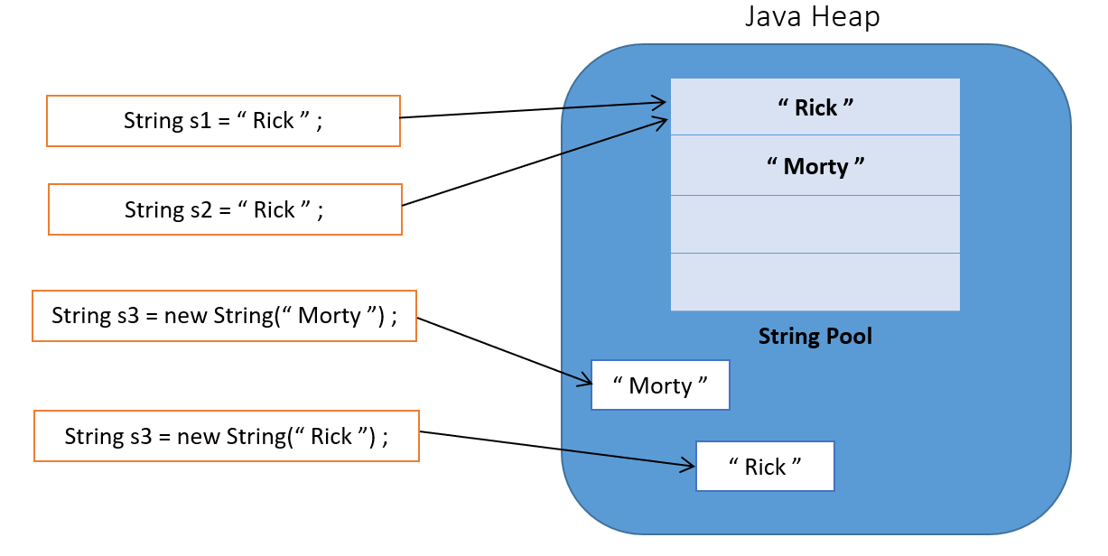

String greeting = "Hello";

## **Java Arrays**

